Year 10
OLNA class

Quiz 2 - 2021

Place Value, Rounding & Estimating


Name: ______________________ Time: 30 minutes (strict) Total Mark:____/24 Weighting : 2%

Resources: No calculator allowed

Question 1 3 marks

Consider the number 39 461 and perform the following:

a) | Round to the nearest thousand
b) | Round to the nearest hundred
c) | Round to the nearest ten

Question 2 1 mark

Add $5, $21.09 and 17 cents

Circle the correct answer
a) $43.09 b) $26.26 c) $26.19 d) $21.76

Question 3 9 marks

Julian is selling tickets for his school’s theatre production of South Pacific. So far he has sold 439 tickets for Thursday night’s performance, 529 for Friday’s and 587 for Saturday’s. The costs of the tickets are $9.80 for adults and $4.90 for students.

a) Round the figures to the nearest hundred to estimate the number of tickets Julian has sold so far.

b) If approximately half the tickets sold were adult tickets and the other half were student tickets, estimate how much money has been received so far by rounding the cost of the tickets to the first digit.

Question 4 7 marks

By rounding the item price to the first digit, use the following table to estimate how much each item will cost for the quantity required.
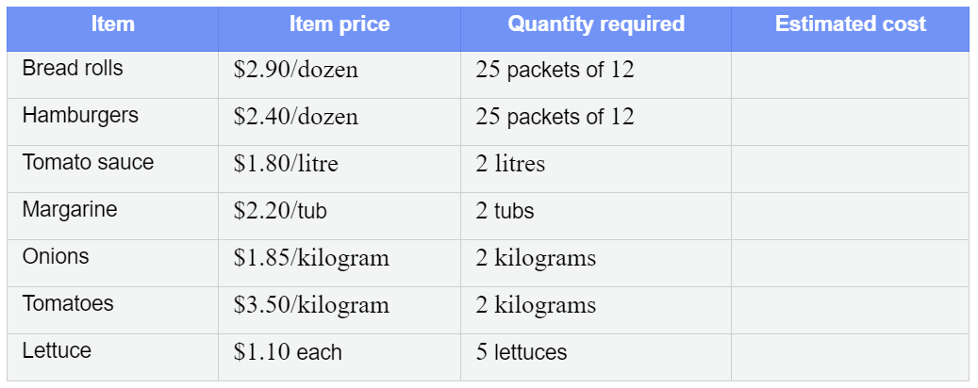
Extra space for working out:

Question 5 1 mark

Change 4075 cents to dollars and cents.

Question 6 3 marks

8249327
For the number above, write the value of the following digits:
a) The value of the 4

b) The value of the 8

c) The value of the largest 2

END OF TEST


Name: ANSWERS Class: ______ Time: 30 minutes Total Mark:____/23

Resources: No calculator allowed

Question 1 3 marks

Consider the number 39 461 and perform the following:

a) | Round to the nearest thousand  39 000
b) | Round to the nearest hundred  39500
c) | Round to the nearest ten
39460

Question 2 1 mark

Add $5, $21.09 and 17 cents

Circle the correct answer
a) $43.09 b) $26.26 c) $26.19 d) $21.76

Question 3 9 marks

Julian is selling tickets for his school’s theatre production of South Pacific. So far he has sold 439 tickets for Thursday night’s performance, 529 for Friday’s and 587 for Saturday’s. The costs of the tickets are $9.80 for adults and $4.90 for students.

a) Round the figures to the nearest hundred to estimate the number of tickets Julian has sold so far.
Thursday – 400 tickets (1 mark) 400+500+600 = 1500 tickets total (1 mark)
Friday – 500 tickets (1 mark)
Saturday – 600 tickets (1 mark)
b) If approximately half the tickets sold were adult tickets and the other half were student tickets, estimate how much money has been received so far by rounding the cost of the tickets to the first digit.
Adult - $10 (1 mark) 750 x $10 = $7500 (1 mark) 7500+3750=$11250 total
Students - $5 (1 mark) 750 x $5 = $3750 (1 mark)

Question 4 7 marks

By rounding the item price to the first digit, use the following table to estimate how much each item will cost for the quantity required.

Extra space for working out:

Question 5 1 mark

Change 4075 cents to dollars and cents.

Question 6 3 marks

8249327
For the number above, write the value of the following digits:
a) The value of the 4

b) The value of the 8

c) The value of the largest 2

END OF TEST

